Astrosage Analysis

Objective Questions
Q-1 What is the total no. of tables present in the data?
Ans Only 1 table was given in data.
Q-2 What is the total no. of attributes present in the data?
Ans Total 35 columns were present in data.
Q-3 The data consists of some inconsistent and missing values so ensure that the data used for further analysis is cleaned.
Ans To handle data inconsistencies removed duplicates, converted date&time ,replaced blanks with “N/A”, formatted numbers and blanks in columns like net amount filled with 0 and removed some columns .
Q-4 What is the change in daily call volume day by day and also find the average of daily call volume?
Ans Change in daily call volume represents the change in the numbers of callers from the last day.it can be simply calculated by subtracting the count of callers from the previous day count of callers.Mathematically change can be represented as (D2 -D1), where D2 represent the today and D1 as yesterday calculated in Change colulm below.
To calculate average daily call volume use =average($B$14:$B$47) (as per value in excel file)
createdAT - Year-Month-Day | COUNTA of CallSid | change | Average_daily call volume
2023-12-01 | 228 | 228 | 246.029
2023-12-02 | 332 | 104
2023-12-03 | 383 | 51
2023-12-04 | 364 | -19
2023-12-05 | 253 | -111
2023-12-06 | 254 | 1
2023-12-07 | 254 | 0
2023-12-08 | 138 | -116
2023-12-09 | 288 | 150
2023-12-10 | 430 | 142
2023-12-11 | 424 | -6
2023-12-12 | 358 | -66
2023-12-13 | 348 | -10
2023-12-14 | 226 | -122
2023-12-15 | 276 | 50
2023-12-16 | 258 | -18
2023-12-17 | 185 | -73
2023-12-18 | 233 | 48
2023-12-19 | 209 | -24
2023-12-20 | 178 | -31
2023-12-21 | 159 | -19
2023-12-22 | 163 | 4
2023-12-23 | 241 | 78
2023-12-24 | 232 | -9
2023-12-25 | 258 | 26
2023-12-26 | 255 | -3
2023-12-27 | 242 | -13
2023-12-28 | 181 | -61
2023-12-29 | 260 | 79
2023-12-30 | 179 | -81
2023-12-31 | 158 | -21
2024-01-01 | 115 | -43
2024-01-02 | 196 | 81
2024-01-03 | 107 | -89
Grand Total | 8365

Q-5 Which months experienced the highest and lowest call volumes?
Ans For the given data Jan 2024 experienced the lesser no. of callers and Dec 2023 has the higher no of callers.
Month | Total no.of calls
Jan | 418
Dec | 7947

Q-6 What is the total operational cost for that month?
Ans Total operational cost is the sum of amount paid to each astroguru by astrosage every month.
Month | SUM of astrologersEarnings
Jan | 5360.408
Dec | 93786.16295

Q-7 What is the average number of calls handled per agent per day?
Ans The average of number of calls handled per agent per day is the total number of calls done divided by the product of total number of gurus and total numbe of days.
Total calls | No. of gurus | Total no.of days | no. of calls per day
8365 | 131 | 34 | 1.8

Which is approximately 2 days.
Q-8 How many repeat callers are there, and what percentage of total calls do they represent?
Ans Those who called more than once are repeat callers ,can be calculated by using COUNTIF function.
According to data Formula used is =countif(N27:N10370,">1") which gives approximately 1275.
To calculate percentage they represent should be total repeat calls divided by total number of calls done. Gives value 57% (Approx.)

no.of repeat callers | Total repeat calls from repeat callers
1275 | 4879 | 58.33%

Q-9 What is the total sales generated by the call centre for each product category?
Ans Sum of sales net amount of each category.
consultation category | Sales
Call | 168442.035
Chat | 45494.68333
Complementary | 0
public_live_Call | 50.597
Grand Total | 213987.3153

Q-10 How many calls were made for each user ID and guru ID?
Ans There are total 8365 calls were made for each user ID and GuruID.

Q-11 What is the correlation between call duration and customer satisfaction?
Ans using function =CORREL(Cleaned_data!AH:AH,Cleaned_data!AN:AN) we get 0.05840372571

Q-12 Which guru have the highest and lowest customer satisfaction scores?
Ans
Tarot Mystical | 7.5 | Highest satisfaction score
Astro Pujaa Rai | 7.5

Tarot Rittika | 0 | Lowest satisfaction score

Q-13 What is the average customer satisfaction score by month?
Month | AVERAGE of rating
Jan | 2.676413255
Dec | 2.949637572
Ans

Q-14 How many categorical columns are there in the data?
Ans 15 (_id, chatstatus, guruName, consultationType, website, refundStatus, freeChat, freeCall, Month, Day, callChannel, callStatus, astrologersCallStatus, region, userCallStatus).

Subjectives Questions

Q-1 Should the investment be used to hire more agents, improve training programs, or upgrade call center technology?
Answer:
Aim:
To get the best area of investment for Astrosage’s call center,I analyzed the dataset using PivotTables, Averages and call /rating distributions.
The analysis is to get idea either we should invest to hire more agents,improve training programs and upgrading technology .
Reference:
- Excel tools Used: Pivot Table , Pie chart, Bar Chart, Column chart
- Functions: COUNT, AVERAGE
Insights and Recommendations:
- For hiring more agents
- Avg. calls per agent per day=2
Total no. of calls/ (Total no. of guru * Total no. of days)
Total calls | No. of gurus | Total no.of days | no. of calls per day
8365 | 131 | 34 | 1.8

May be due to workload imbalance the no. of calls handled by some guru is moch more than the other.

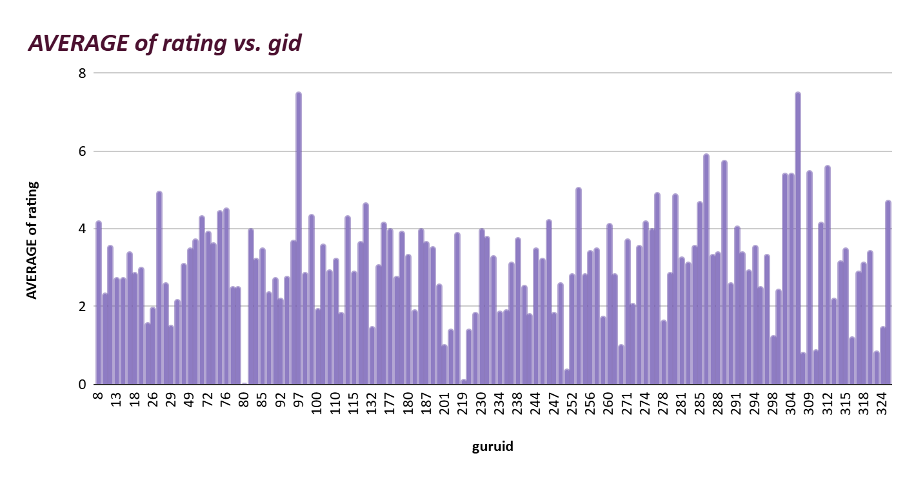

Insights:
The current workforce is not overburdened; inefficiency is due to
Uneven call distribution among callers not a manpower shortage.
Recomendation:
Instead of hiring now it will be better to focus on equal call
Distribution.
- Improving Training Programs
- Number of gurus getting a good rating is too low.
- Most of the gurus can’t even rated above 5 (Only 11 gurus got an average rating above 5)

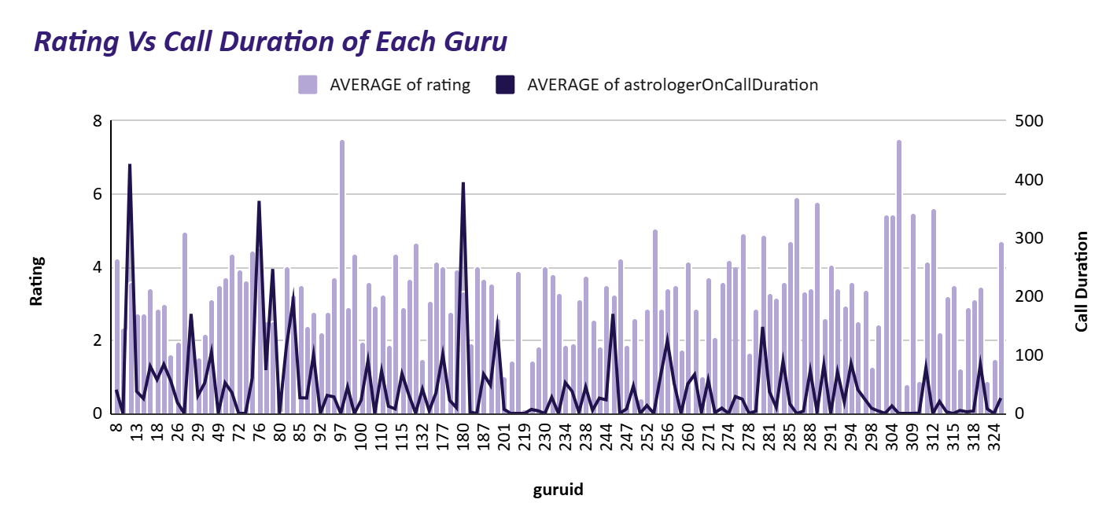
Insights: Lack of communication skill left the customer unsatisfied with
the call
Recommendation:
Provide training modules and coaching to improve the skills required and analyze the change in their performance.

- Upgrade Call Center Technology
- Only the 33% calls are completed succesfully ,other 67% were
Either failed,incomplete,not answer or busy.
- The difference in the unsuccessfull calls shows a lack in technology .
Insights:
May be due to use of outdated technology there can be direct call
droping and decreasing the productivity

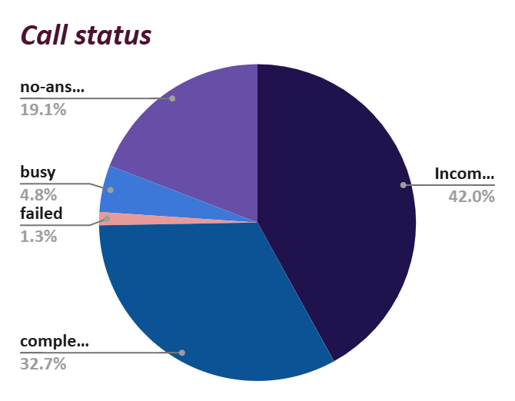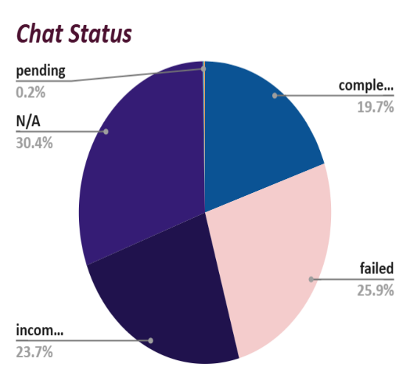
Recommendations:
Improve call back systems to get back to user failed to answer or busy. Track not-answered calls and N/A chat status reasons.
Q-2 What are the potential risks of each investment option (hiring, training, technology upgrades), and how can they be mitigated?
Answer:
Aim :
To identify the potential risk of investment and mitigation strategies for hiring, training and technolgy upgrades.
Reference : Excel Tools used : PivotTables , Stacked Column chart
Function used: Count()
COUNTA of CallSid | Weekday
Hour | Wed | Tue | Thu | Sun | Sat | Mon | Fri | Grand Total
0 | 16 | 6 | 9 | 19 | 7 | 9 | 2 | 68
1 | 10 | 10 | 10 | 3 | 1 | 12 | 6 | 52
2 | 14 | 23 | 10 | 22 | 31 | 8 | 21 | 129
3 | 34 | 42 | 26 | 29 | 49 | 48 | 36 | 264
4 | 58 | 65 | 34 | 40 | 46 | 69 | 36 | 348
5 | 46 | 74 | 56 | 65 | 50 | 92 | 66 | 449
6 | 65 | 54 | 60 | 118 | 77 | 67 | 100 | 541
7 | 96 | 72 | 70 | 93 | 71 | 72 | 77 | 551
8 | 90 | 93 | 79 | 83 | 102 | 122 | 91 | 660
9 | 57 | 76 | 56 | 75 | 89 | 94 | 51 | 498
10 | 108 | 73 | 46 | 112 | 92 | 98 | 76 | 605
11 | 58 | 71 | 31 | 98 | 86 | 114 | 57 | 515
12 | 74 | 58 | 34 | 95 | 72 | 114 | 36 | 483
13 | 50 | 68 | 60 | 64 | 52 | 89 | 54 | 437
14 | 75 | 69 | 55 | 87 | 68 | 96 | 63 | 513
15 | 73 | 98 | 49 | 78 | 88 | 53 | 58 | 497
16 | 33 | 77 | 44 | 85 | 89 | 84 | 67 | 479
17 | 27 | 73 | 35 | 87 | 51 | 55 | 46 | 374
18 | 32 | 48 | 19 | 58 | 41 | 32 | 35 | 265
19 | 33 | 36 | 15 | 26 | 45 | 31 | 37 | 223
20 | 30 | 42 | 9 | 19 | 42 | 14 | 16 | 172
21 | 16 | 18 | 1 | 19 | 17 | 12 | 16 | 99
22 | 24 | 3 | 3 | 5 | 24 | 5 | 9 | 73
23 | 10 | 22 | 9 | 8 | 8 | 4 | 9 | 70
Grand Total | 1129 | 1271 | 820 | 1388 | 1298 | 1394 | 1065 | 8365
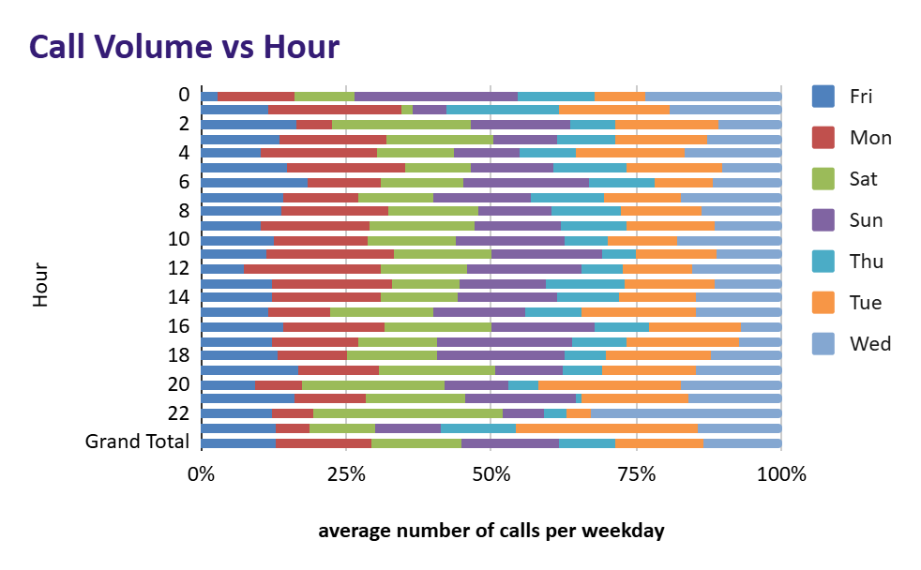
- To hire more Agents
Risks:- i) increase in cost to company.
ii)Overstaffing of employees .
Mitigation :-i) Hire staff aligned with the calls demands identified by call volume charts.
ii)hire skilled agents using competency-based recruitment.
iii)Maintain the performance records of agents.

- For Training programs
Risks:- If they are not able to adapt themselves to newly learned things or
ROI is not as much as expected .
Mitigation:-i) provide the mentorship programs from high performers.
ii)analyze the improvement status by maintaing records.
iii)trainers should be well skilled in their program.
- Technolgy upgrades
Risks:-need of high upfront investment cost and uncertain payback time.
- Staff needs time to get hands on new technology .
Mitigation:-i) opt for more user friendly systems.
ii) provide post implementation and onboarding sessions for
smother adaptation process.

Q-3 How does AstroSage call center performance compare to that of AstroGuru in terms of average call volume, customer satisfaction, and agent performance?
Will you use any aggregation function or a visualization here to solve the problem?
Answer: For the comparison of AstroSage and AstroGuru, we currently do not have any dataset for AstroGuru. However, hypothetically, if the dataset were available, the analysis could be performed as follows:
- Call Volume Analysis
- Using Pivot Tables, calculate the total number of calls and average daily calls for AstroSage.
- Compare these values with AstroGuru’s dataset to identify call handling capacity.
- Visualization: Line Chart or KPI cards for call trends.
- Customer Satisfaction (Ratings)
- Create a Pivot Chart for user-wise and astrologer-wise ratings.
- Compare the satisfaction levels of both call centers side by side.
- Visualization: Clustered Bar Chart or Column Chart.
- Agent (Guru) Performance
- Build a Pivot Table showing calls handled vs. astrologer name.
- Identify the top-performing astrologers in AstroSage and benchmark them against AstroGuru’s top performers.
- Visualization: Bar Chart for agent performance and leaderboard charts for top consultants.

Q-4 How can the call center improve its handling of peak call periods to ensure high customer satisfaction?
Answer:
Excel tool used: Pivot table ,Column Chart , Conditional Formatting
Functions Applied : COUNT()
Key Metric : Number of Calls by time on each weekday.
Insights:-The number of callers on sat, sun and mon are more than any other day and the peak timings are 6 a.m. to 12p.m. Hence , these time slots should be more managed to avoid any unneccessary dissatisfaction among users.
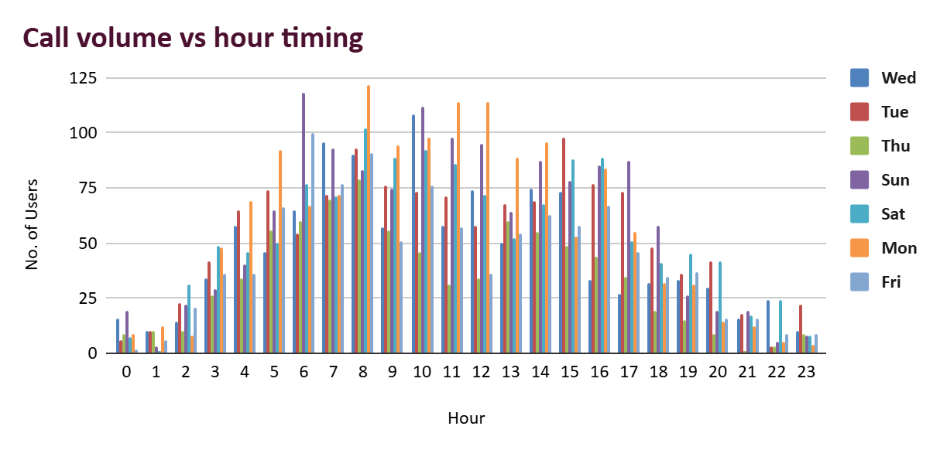
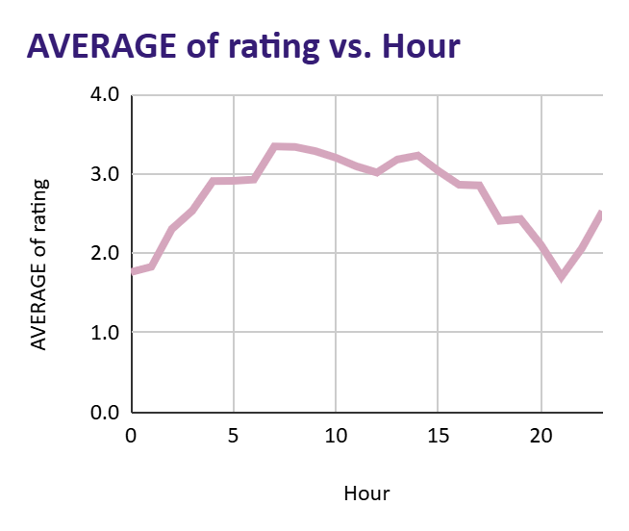
Recommendations:-
- Try to more agents during peak timing slots.
- Assign calls with faster resolution rates using performance data.
- Use IVR menus and Chatbots to handle FAQs and easy queries.
- Keep agents availability records prior.
Q-5 Based on historical data, what strategic initiatives should be prioritized to improve overall efficiency and customer satisfaction?
Answer:
Analyze call completion,repeat calls and rating distribution to identify
Inefficiencies.
Insights :-
- Only 41.26% of total calls are completed sucessfully rest are busy,
failed, incomplete or not answered .
- 58% users were repeat calls i.e. 4879 calls hence their must not been
resolved in one go.
- Only 20% of chat were completed sucessfully rest are failed to
complete or not available .
- Most of the calls are rated below average.
Too much gap in rating of top and bottom gurus represent the uneven skill level.
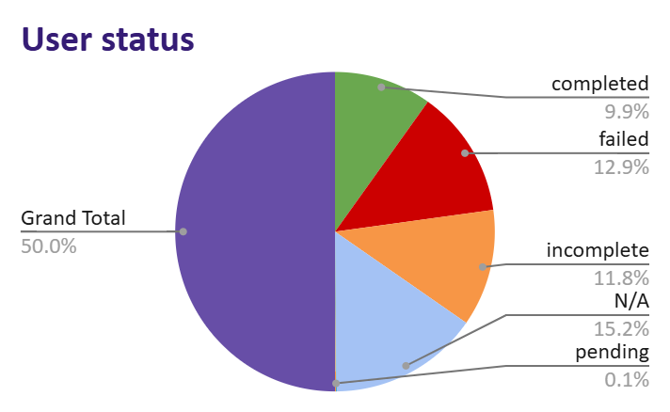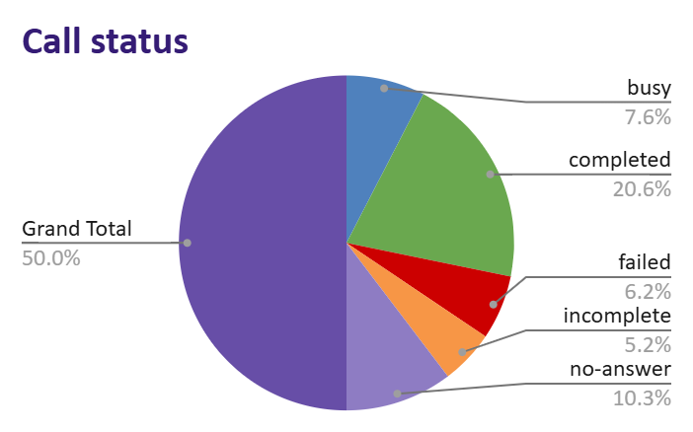
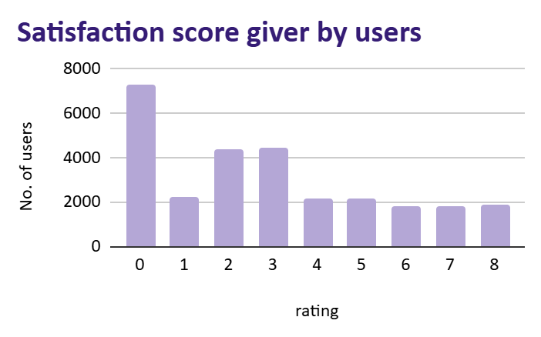
Tarot Mystical | 7.5 | Highest satisfaction score
Astro Pujaa Rai | 7.5

Tarot Rittika | 0 | Lowest rated Guru
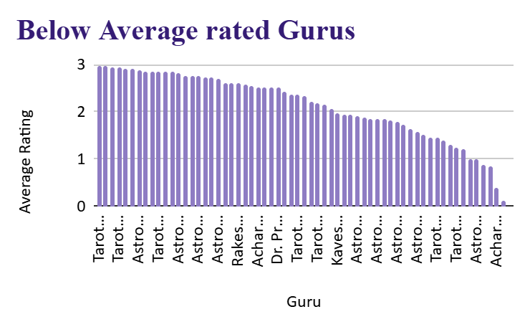
Recommendations:-
- Enhance the distribution of calls to reduce the chances of failed /busy not answered calls.
- Use top performing Guru’s techniques to guide and train other gurus too.
- Provide a little training programme to low performers.
- Analyze the reason of too much repeat calls.
- Establish performance dashboards linking agent KPIs with FCR and customer satisfaction scores.
- Offer incentives or recognition programs for consistent high performers to maintain motivation and quality.

Q-6 What can be the key factors contributing to high customer satisfaction scores, and how can these be leveraged to improve overall performance?
What is the basis for the suggestions? And mention how did you decide if the satisfaction score affect the ratings?
Answer:-Insights:-
- Customers whose calls or chats were successfully completed showed significantly higher ratings.
- Incomplete, failed, or busy interactions directly correlated with low satisfaction levels.
- Thus, service accessibility and completion are the strongest predictors of positive feedback.
- Gurus like Tarot Mystical and Astro Pooja Rai consistently achieved average ratings around 7.5.
- Scores of 0 accounted for approximately 7,256 cases (~26%), representing a major portion of negative experiences.
Recommendations:-
- Use top performing Guru’s techniques to guide and train other gurus too.
- Collect insights and direct feedback from customers rating 6–8 to identify specific drivers of satisfaction.
- Enhance call routing efficiency and load balancing to reduce busy or failed calls.
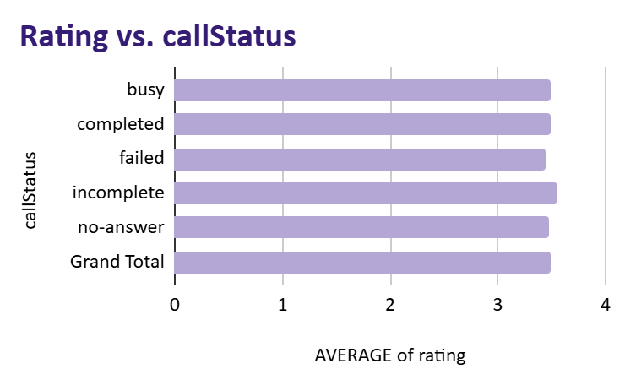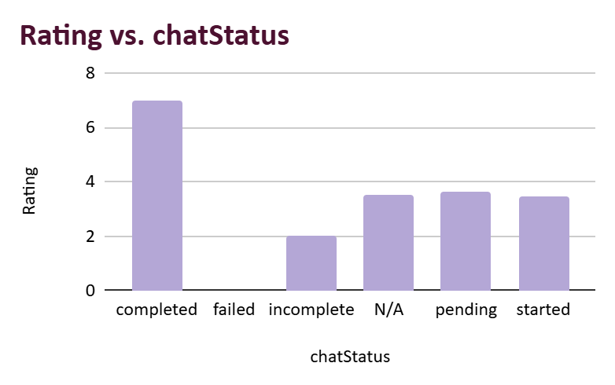


Q-7 How should the call center balance the workload among agents to ensure optimal performance and avoid burnout?
Mention your approach and spreadsheet function for the answer?
Answer:- Visualizing the distribution with bar charts and histograms helped pinpoint extreme variations in workload intensity.
Excel Tools Used: - PivotTable (Guru vs. Consultation Count),Bar Chart /
Histogram (Workload disparity visualization).
Insights:-
Astro Trisha Handled 370 sessions,Vandana Bhutani handled 142 sessions and Daljit Kaur handled 111 sessions which shows the uneven distribution calls and workload on these top gurus as well.
Astro Rajesh S handled 704 sessions,Astro yogendra handled 735
Sessionsand dr. Harish handled 405 sessions and many other too handled more than average sessions per guru . hence, these might be the reason of their low performance . While some got less than 10 sessions like Tarot Ritika and Astro Rohan and many more.
Astro divya got 1056 sessions to handle ,Astro shalini got 1321 sessions and Astro Krishaa handled 1580 session with average rating of 3.4.
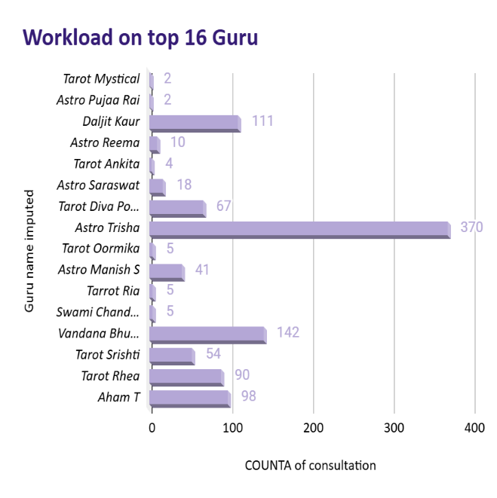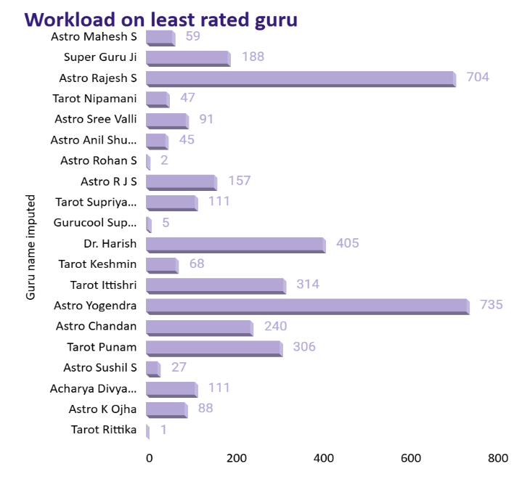

Total calls | No. of gurus | Total no.of days | no. of calls per day
8365 | 131 | 34 | 1.8

Recommendations:-
- Calculate the average consultations per Guru and use it as a benchmark.
- Align top astrologers’ working hours with peak call periods (8 AM–12 PM) for maximum impact.
- Encourage top-performing Gurus to share best practices with others through internal training.
- This helps raise the overall service level and reduces dependence on a few high performers.
Q-8 What new technologies or tools could be implemented to enhance call center operations and customer service?
Answer:
- Introduction to chatbots and Virtual assistants for regular queries can help in saving the consultants energy for complex queries and consultations.
- Use of AI for personalization based on some insights of customer for better user experience can result in repeat orders/consultations.
- Maintaining a CRM software about past consultations and customer details can help in future consultations and targeting old customers.
- Feedback mechanism should be adopted to make the customers happy and improve the quality.
- Personalized pre-booked video sessions with consultants can help in the repeat customers as the interaction helps in understanding the customer behaviour.
- Developing apps with different notifications and games such as puzzles and making the customers learn about the birth charts and planets attract new customers. 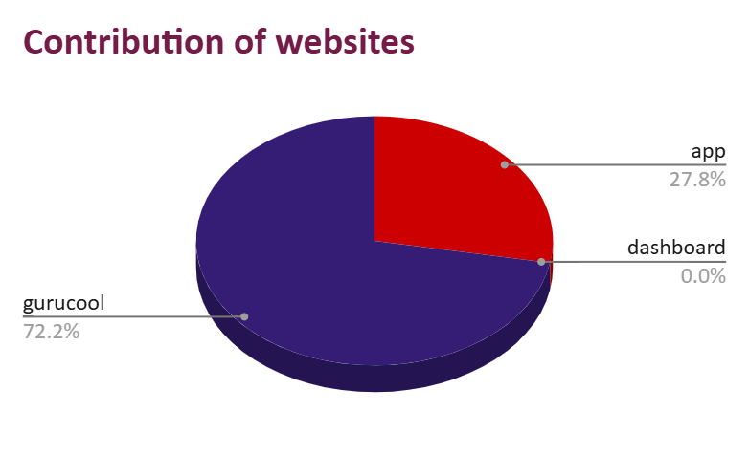

Q-9 What metrics should be included in the final dashboard to provide a comprehensive view of call center performance and guide investment decisions?
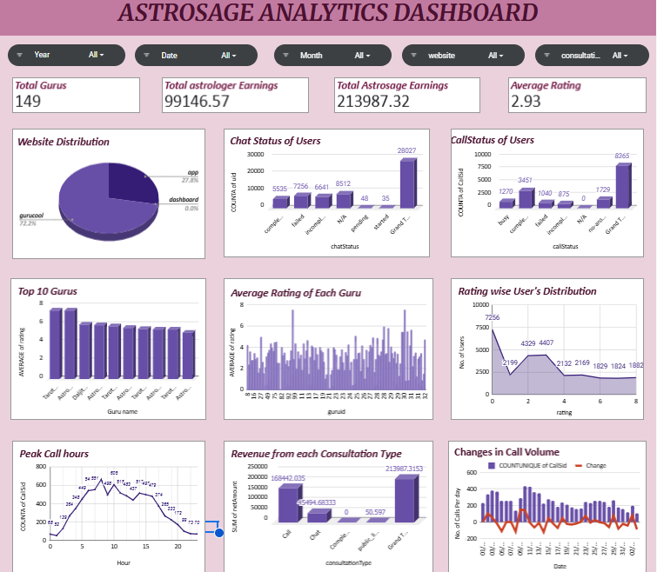
Visuals : pie chart
Bar chart
Line chart
Slicers: Chat status
Call status
Guru Name
Refund Status
Formulas: Average
Countifs
Sumifs
The dashboard integrates multi-dimensional KPIs—Financial, Customer Experience, Operational Efficiency, and Workforce Quality—to track profitability, satisfaction, and productivity simultaneously. Using PivotTables, charts, and slicers, data is summarized to reveal strengths, inefficiencies, and improvement areas.
Insights:
i) Total Revenue reflects overall business health and agent ROI.
ii) Revenue by Consultation Type shows that certain services (e.g.,
paid calls) generate higher margins, guiding investment.
iii) Repeat Caller % (~57%) signals poor first-call resolution,
indicating a need for better scripts or technology support.
iv) Retention Rate (if tracked) reveals loyalty and long-term service
quality.
v) Average Calls per Agent (~2/day) indicate underutilization and
uneven load distribution.
vi)First Call Resolution (FCR) closely aligns with customer
satisfaction trends.
Recommendations:
- Integrate All KPIs in a Unified Dashboard: Present financial, customer, operational, and workforce data together for holistic decision-making.
- Invest in Technology Upgrades: Improve call routing, IVR, and CRM systems to raise completion and FCR rates.
- Optimize Workforce Utilization: Rebalance workloads, schedule efficiently, and share best practices from top performers.
- Enhance Training & Incentives: Focus on empathy, communication, and problem-solving to boost CSAT and retention.
- Enable Interactive Analysis: Use slicers and filters to identify month-wise, guru-wise, or service-type performance trends quickly.
Q-10How would you allocate a 1 crore rupee investment to optimize operational efficiency, enhance customer satisfaction, and boost profitability, and what analysis-based recommendations would you offer to support this?
Answer:Analyzed historical performance metrics including call outcomes, repeat callers, agent utilization, and satisfaction scores to identify key operational bottlenecks. The investment of ₹1 crore was distributed strategically among Technology, Training, Incentives, and Hiring based on issue severity, ROI potential, and long-term sustainability.
Insights:• Operational Inefficiencies: 59% of calls were not completed (busy, failed, no-answer) — showing major system and routing gaps.
• Workload Imbalance: 148 agents handle an average of only 2 calls/day — underutilization and uneven distribution of work.
• Customer Dissatisfaction: Average CSAT <3/8 and 58% repeat calls indicate unresolved queries and poor first-call resolution.
• Performance Gap: Wide rating difference between top and low-rated gurus reveals inconsistent service quality and lack of structured training.
Recommendations:
Investment Allocation (₹1 Crore):
• Technology Upgrade – ₹40L (40%): Invest in CRM and system upgrades to reduce failed calls, automate routing, and improve completion rate.
• Training & Development – ₹35L (35%): Launch “Guru Excellence Program” focusing on communication, empathy, and FCR improvement.
• Performance Incentives – ₹15L (15%): Introduce reward schemes linked to CSAT and efficiency metrics to motivate consistent performance.
• Phased Hiring – ₹10L (10%): Hire selectively once efficiency improves, to balance workload and sustain performance levels.

Executive Summary:
Focus first on Technology and Training (75%), as they directly address inefficiencies and satisfaction issues. Incentives (15%) drive short-term motivation, while Phased Hiring (10%) ensures long-term scalability. This balanced strategy ensures efficiency, enhanced satisfaction, and improved profitability.

